To,
ATT QUOTATION

{customerName}
{customerAddress}
Subject : {subject}

DATE: {quotationDate}
QTN: {quotationNumber}

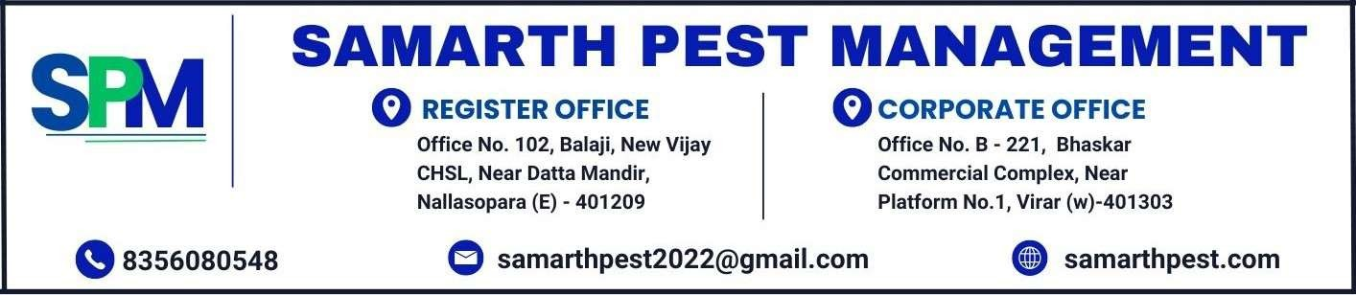
Respected Sir,
We thank you very much for your enquiry and the opportunity given to us to quote our rates. Further to your instructions, we are pleased to submit our quotation as below. It is our commitment to provide you with the best and reliable services.

Premise To Be Treated | {premises}
Specification | {specification}
Equipment | {equipment}
Payment Terms | {paymentTerm}

Type Of Treatment | Period of Warranty | Chemical Used | Service Charges
{#treatments}{typeOfTreatment}  Anti Termite Pre-construction Treatment | {warrantyPeriod}  10 Years | {chemicalUsed}  Imidacloprid 30.5 % SC of m/s Bayer (Envu) | {serviceCharges}{/treatments}  Rs. 65/-- Per Sq. Mtr.
- The above quote is exclusive of GST and will be charged as per applicable rate.
In case of subterranean or ground dwelling of termite infestation during the warranty period, We undertake to treat the same and eradicate the termite infestation without any extra coast to you. This warranty will be forwarded on stamp paper.

We trust that our proposed solution is acceptable to you and we await your favourable reply. Thank you for your interest in Samarth Pest Management. Yours faithfully,

For Samarth Pest Management

